**JFSD: A-Z of Back-end and Database Development**

**Day 11 : 17 Aug 24**

Limitation of JSP

1. Jsp is type of servlet when we run the jsp program on browser with help of servlet. JSP internally convert into servlet. That phase is known as page translation phase. Performance wise jsp is slower than servlet.
2. If we write any business logic or database login in jsp page. That code end user or client can view. So JSP is not secure.
3. In JSP page we can’t do re-usability properly. because in JSP page we can write more than scriptlet tag. For those tag no name. if we want we can include or forward whole jsp page. But not part of the page. But if we write that logic in normal class inside a method those method we can call again and again.

Dbinfo.jsp

<%

Jdbc Code to insert the record

%>

<%

Jdbc delete to insert the record

%>

So can we write business logic or jdbc logic inside Servlet. Ie doGet or doPost.

If we write jdbc or business logic inside doGet or doPost that code become local to that servlet. Because we are not creating servlet object and that code we can’t do re-usability.

We need to use one of the very important design pattern. Ie MVC

View : jsp or html (web) or console in (core Java)

Login.jsp page which contains emailid and password and action LoginController with doPost method.

Success.jsp

Failure.jsp

Controller : Servlet (web) or main class (core Java)

doPost

receive the value from view ie login.jsp using request.getParameter() method. then create Login class object and set the value with help of setter or constructor. Then create LoginService class object and pass this object to service layer. Base upon service layer result it redirect to specific view page.

Model javabean class, service class, dao class and resource class.

Service : pure business logic

If we need any business logic. Please apply that business logic.

If condition satisfies then create dao class object and pass the value to dao layer

Data Access Object 🡪 pure jdbc code

In Dao layer we write database logic using jdbc to check login details or singup functionality.

In each dao method rather than doing load the driver and establish the connection this code we can write in resource layer.

Resource -🡪 database Connectivity

This layer responsible to provide the database connection.

Java -🡪 variable setter and getter method that class map to table in database.

We need to create dynamic web project with version 4 but select web.xml file.

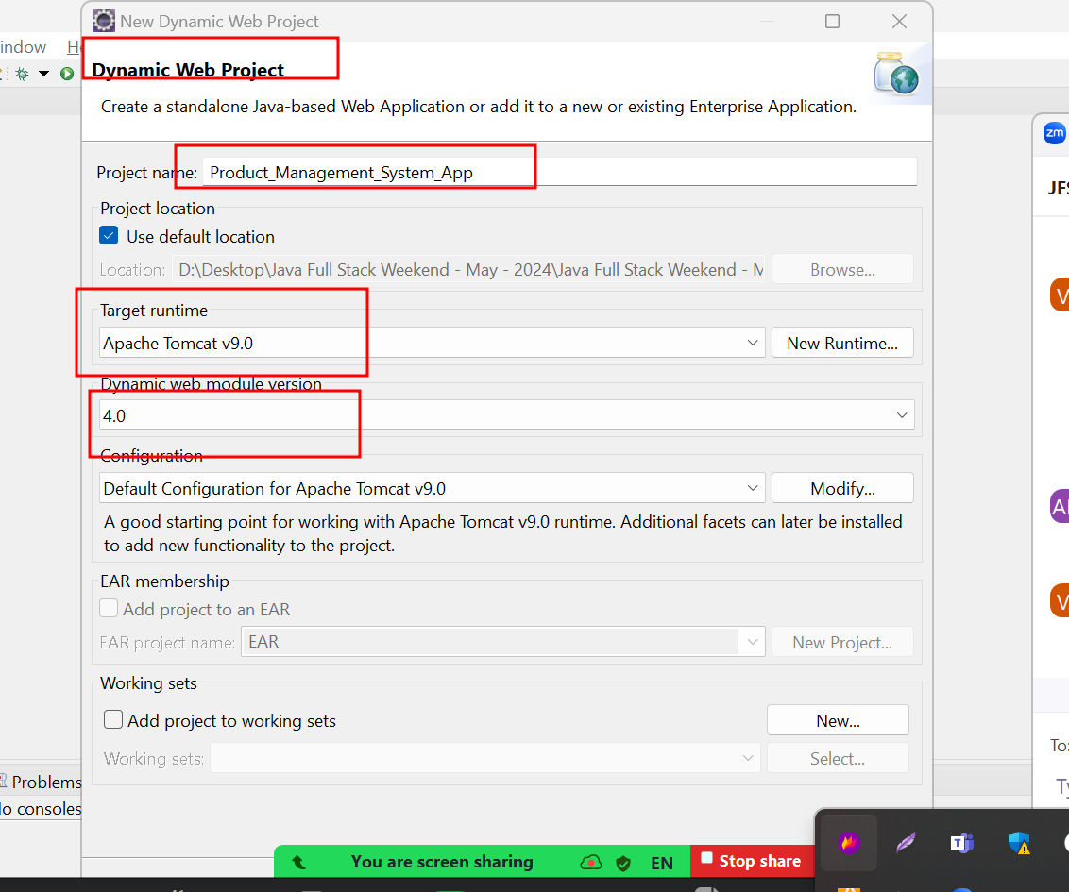

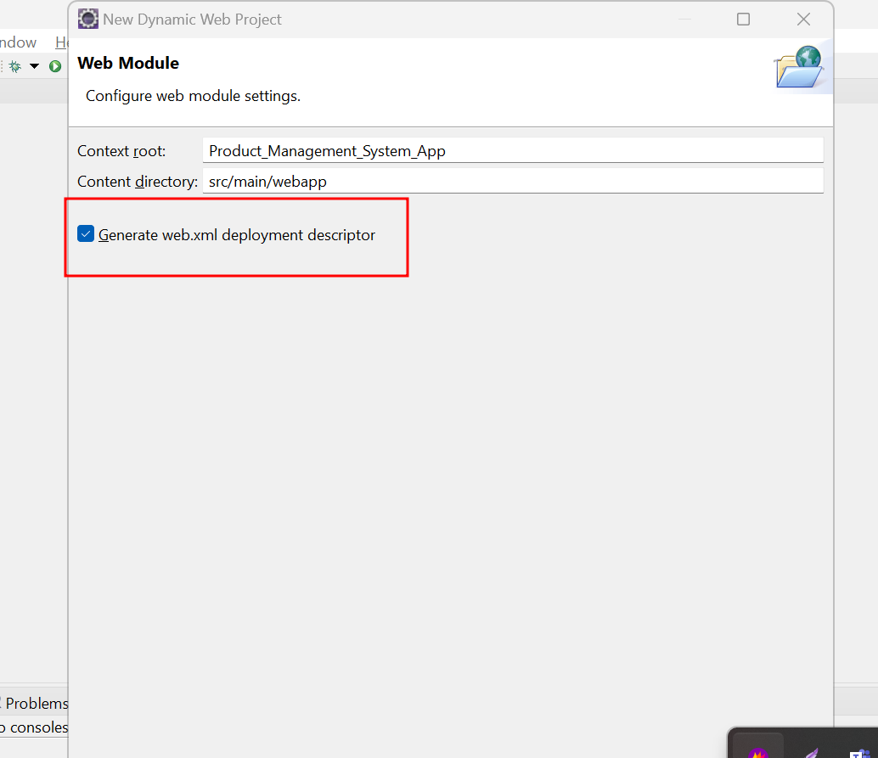

Now we need to convert this project to maven project

Please right click on project and select the option as configure and select the option convert to maven.

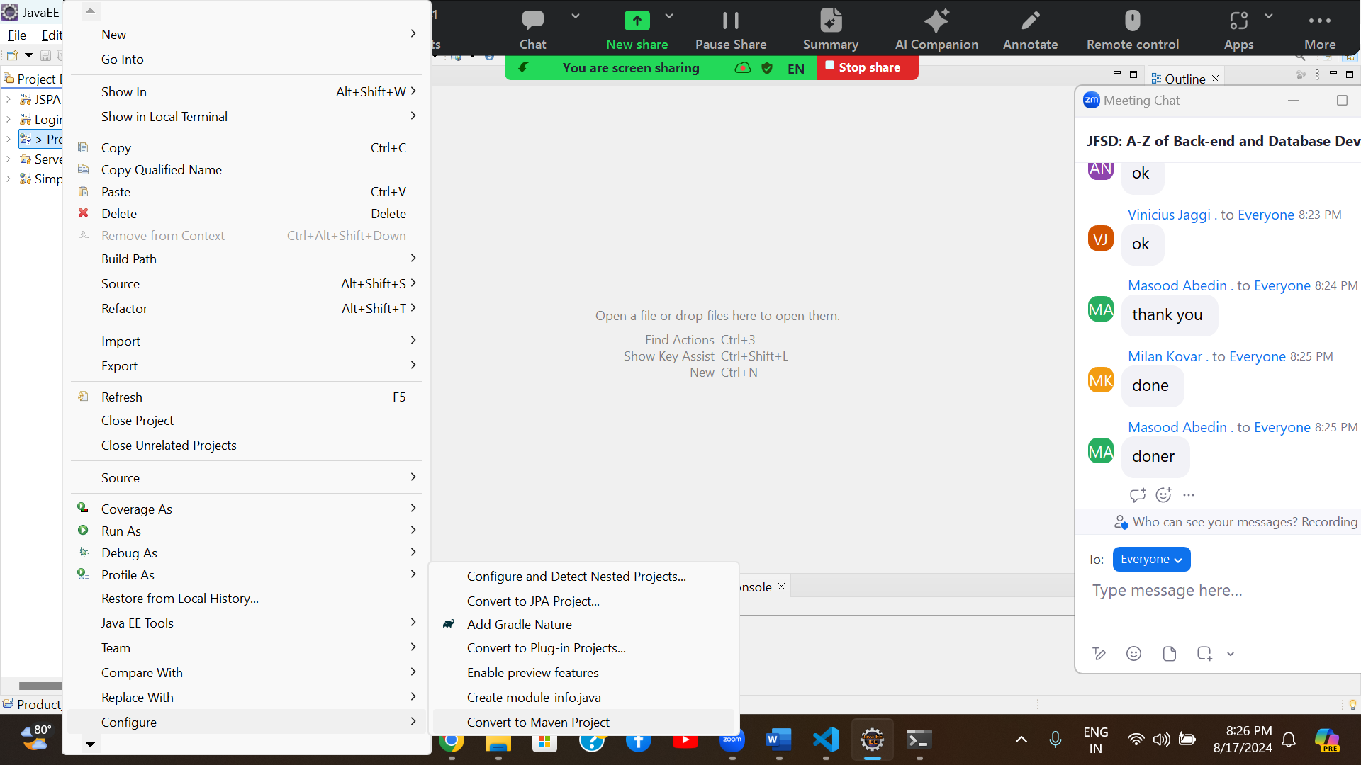

After convert dynamic web project to maven. Please change the version of java ie 11 and add the dependencies ie mysql connector

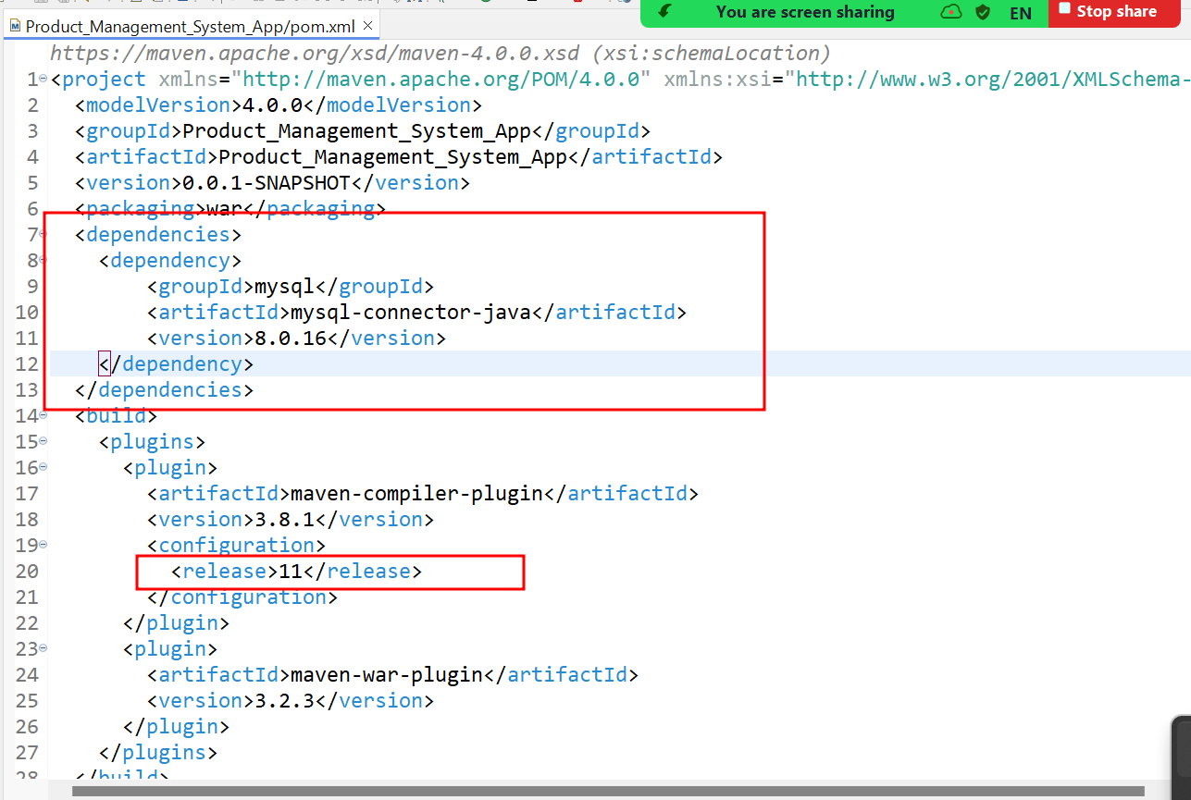

Now we will create five jsp page.

index.html

add_product.jsp

delete_product.jsp

update_product.jsp

view_product.jsp

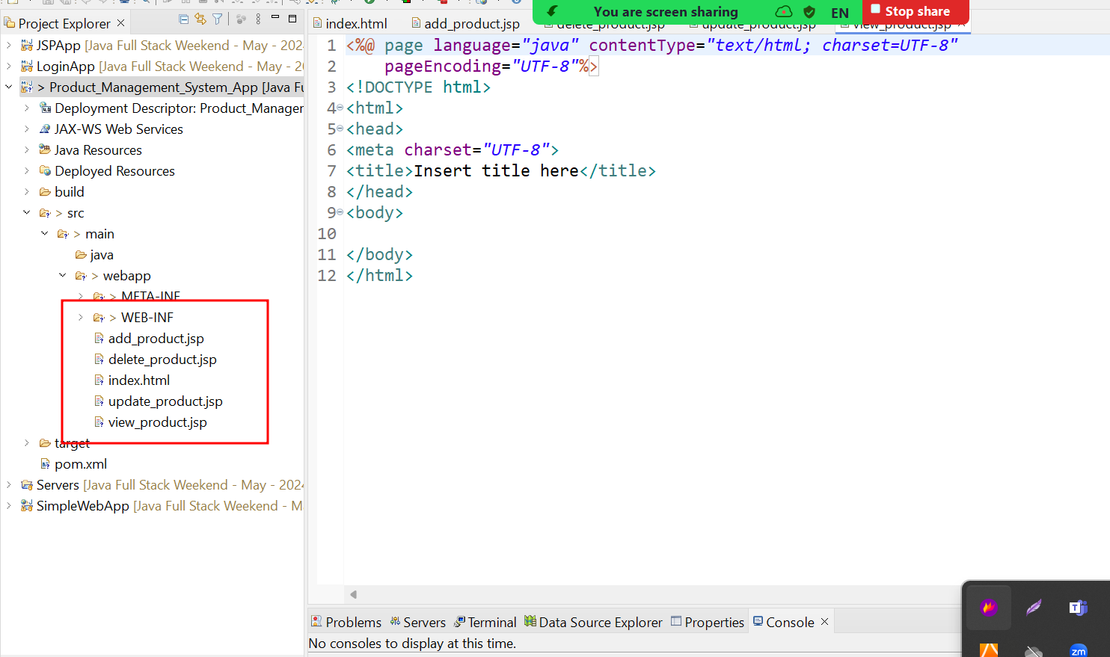

We create packages

controller (servlet class)

service (normal class)

bean (normal class)

dao (normal class)

resource (normal class)

